SIMATS ENGINEERING (SAVEETHA SCHOOL OF ENGINEERING)
Department of Computer Science and Engineering
ASSESSMENT TOOL 2 – Concept Mapping

Course Code: | CSA0305 | Course Title: |  | Data Structures
CO Assessed: | CO1 – Imitation (BL3, BL4) | Assessment: |  | Assessment Tool 2 – Concept Mapping
Weightage: | 35% of CIA | Total Marks: |  | 100
CO1 Statement: | Apply suitable data structures and ADTs for efficient problem solving by analyzing time and space complexity.
Student Name: | SIVA CHARAN |  | Reg. No.: | 192525039
Section / Batch: | 2025 |  | Date: | 10/07/2026
Code of Conduct
I Siva Charan (192525039) (Name / Reg No) certify that this submission is my original work and that I have adhered to the guidelines specified for this assessment. I understand that any violation of academic integrity rules will result in disciplinary action.
Signature of the Student: Siva Charan
Instructions
- This test contains 5 Concept mapping questions. Total: 100 Marks.
- When a student answer using a concept map, in evaluation the answer should be with following four requirements: Understanding of concepts, Connections between ideas, Logical structure, Clarity of representation.
- No negative marking. Unanswered questions carry zero marks.

Section / Topic | Focus | Q Nos | Marks
Linked data structure | Basic data structure | 1 | 20
Primitive and Non-Primitive Data Structure - Linear and Non-Linear Data Structure | Classifications of Linear data structure | 2 | 20
Search Data Structure | Linear Search and Binary Search | 3 | 20
Recursion, Performance analysis | Recursion | 4 | 20
Tree Data Structures | Classifications of Tree data structure | 5 | 20
GRAND TOTAL: |  | 100 Marks

Annexure A – Concept Mapping

- A student attendance system records daily presence data. Construct a concept map linking Array → Fixed Size → Sequential Access → Linked List → Dynamic Allocation → Flexibility.
Explain how each structure works and justify which is more suitable for dynamic data updates. (20 Marks)
- A weather monitoring system collects temperature, humidity, and wind data continuously. Construct a concept map linking Primitive Data Types → Non-Primitive Structures → Linear Structures → Non-Linear Structures → Applications. Include examples and explain how each structure supports continuous data processing. (20 Marks)
- A digital archive stores millions of documents. Construct a concept map linking Searching → Linear Search → Binary Search → Sorted Data → Time Complexity → Performance. Analyze
the impact of data organization on search efficiency and justify the best technique.
(20 Marks)
- A program processes nested expressions using recursion and may encounter deep nesting. Construct a concept map linking Recursion → Call Stack → Stack Overflow → Error Handling
→ Efficiency. Analyze potential issues and justify strategies to handle them. (20 Marks)
- A company maintains hierarchical employee records with multiple levels of management.
Construct a concept map connecting Tree → Nodes → Levels → Traversal (DFS/BFS) → Searching → Efficiency. Analyze how traversal techniques affect performance and justify the most suitable approach for retrieving employee data. (20 Marks)
Rubrics for Calculation
Criteria | Weightage | Level 4 – Exemplary | Level 3 – Proficient | Level 2 – Developing | Level 1 – Beginning
Understanding of  Problem Context | 20 | Clearly understands the problem and accurately identifies all requirements | Good understanding with minor gaps | Basic understanding; some requirements unclear | Poor understanding or misinterpretation of the problem
Application of Concepts | 30 | Accurately applies appropriate concepts to solve complex problems | Applies relevant concepts correctly with minor errors | Applies basic concepts with limited accuracy | Fails to apply appropriate concepts
Problem-Solving Approach | 20 | Logical, well-structured, and efficient approach | Mostly logical approach with minor gaps | Basic approach with some inconsistencies | Illogical or unclear approach
Accuracy of Solution | 20 | Completely correct solution with proper justification | Mostly correct with minor errors | Partially correct solution | Incorrect or incomplete solution
Clarity | 10 | Clear, well-organized, and properly explained solution | Understandable with minor clarity issues | Limited clarity and explanation | Poorly presented and difficult to understand

Faculty In-charge | Course Coordinator | Program Director
Signature: | Signature: | Signature:
Date: | Date: | Date:

1.ATTENDNANCE MARKING RECORDS
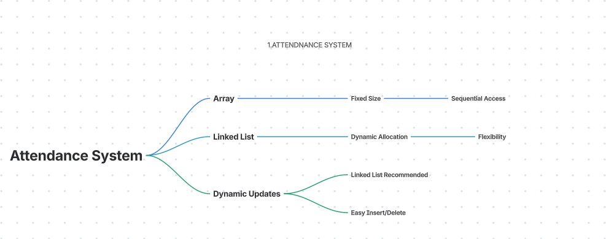
WEATHER MONITORING SYSTE,
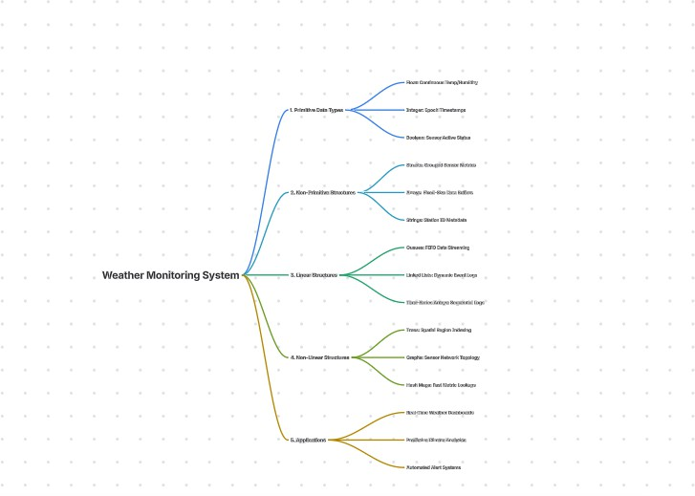

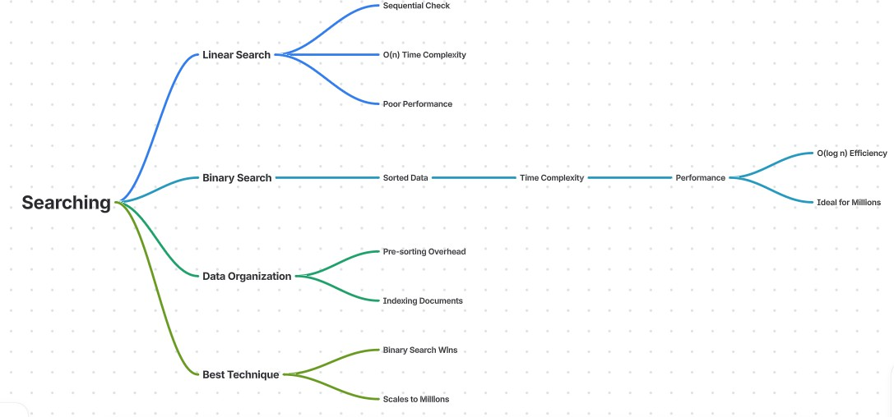
- DIGITAL DOCUMENTS STORAGE

- RECRUSIION IN NESTED EXPRESSION
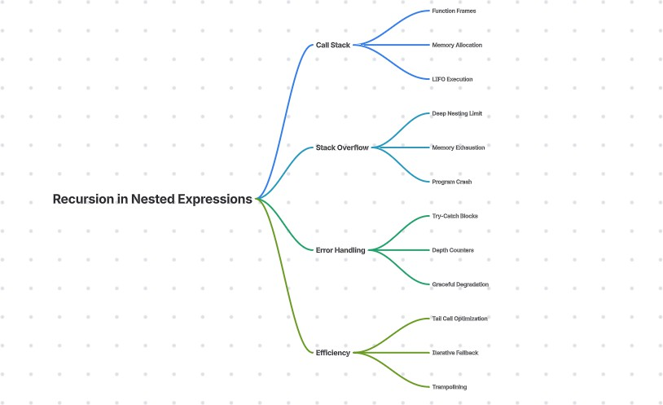

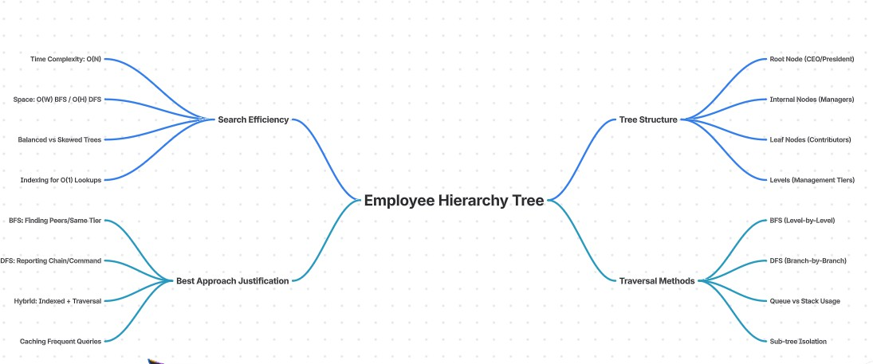
- HIERARCHICAL EMPLOYEE RECORDS

